Manuel Romero Musical Genre Pop Regional

Latino Heartthrob, Brave, Strong, Confident, Role Model

Fantastic Artist, singer songwriter that thrills all audiences!

His message is one that inspires people to be all that they can be. This message leads to individual greatness. Manuel Romero is clean cut and produces real, long lasting music for all generations. Manuel is a singer-songwriter musician. His current group consists of a live band, professional back up dancers, singers and a Rap Artist. Manuel’s stage presence is commanding and connecting, his pure original sounding voice on a recording is just as clean and powerful during a live performance. His looks and personality are expensive, polished, classy, warm and good. He is charismatic and can easily socialize with dignitaries yet his humble nature makes him the voice and man of the pueblo. Manuel is bilingual and bicultural. He is able to empower all thru music. He is known for swooning and entrancing the ladies in the audience. Manuel loves Mexican food, tacos and a great party!
Market
Hispanic female teens and young adults are the growing purchasing power in the USA and that is his target market.
Short Term Plan
Manuel recently released the Quince ReMix/Birthday Queen Song. This song is an instant upbeat crowd pleaser. Manuel travels around the country performing his new hit. Manuel plans to continue live performance and auditioning for TV and Movie roles. Manuel enjoys performing at local High Schools to promote education,
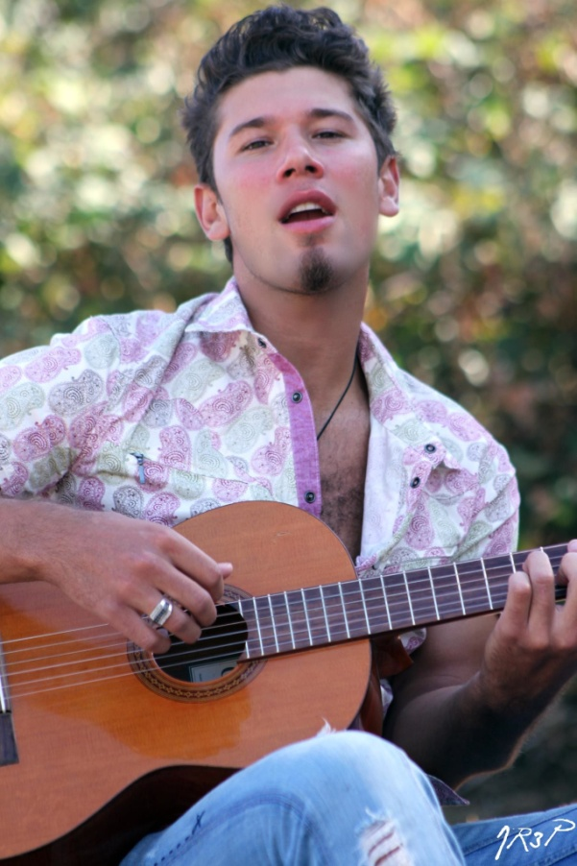

family, and morals; a message to the young people that you can attain your dreams with hard work and dedication. Manuel’s music sends a message that speaks of staying strong and healthy, and one that keeps families together.
Long Term Plan
Crossover to the mainstream and International markets in Enlgish.
Experience
Grammy Camp Scholarship Recipient
People en Español Commendation
Todos A Cantar Televisa MX Finalist
America’s Got Talent Top 20
Warner Music Latina Artist
Most Influential Latino Silicon Valley
Golden Boy Promotions Events
Performances
National Radio & TV
Live Concerts
Raiders/49er’s Anthem & Half-time
Giants/A’s/Warriors/others
Former-President Fox of Mexico
Former-President Zedillo of Mexico
Pope John Paul II
Former-President Toledo of Perú
Collaborations
Rafa Sardina
Juan Carlos Paz y Puente
Narada Michael Walden
Jon Cain
Stage
Buddy the Buddy Holly Story (LA/San Jose)
Altar Boyz(Juan)
Movies
El árbol de la horca (Mexico)
Commercials
Many
Works
Orgulloso de Ser-Romero Bros.
Christmas is Comin’-Romero Bros.
Santa Maria-Romero Bros.
Manuel Romero-Warner Music Latina
Music of Love-Narada Michael Walden
El Mix de Manuel Romero-MRF Entertainment
Albums Sold
40,000
Fans
5000 on mailing list

Competition
Intocable
Material
Como Hace Quince Años
Birthday Queen with Rapper VictorRomero
Rompe Corazones
Me Volví a Cruzar
Links
Como Hace Quince Años
Birthday Queen ReMix
El Grito
Gettin Out There
Manuel Romero
Contact
Manuel Romero
P.O. Box 612556
San Jose, Ca. 95161
408.942.7464
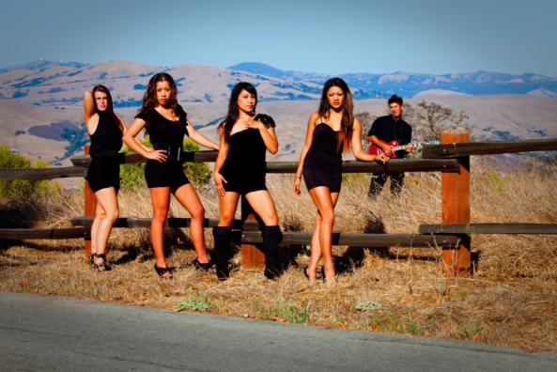 Manuel Romero & Back up dancers 2011
Victor Romero, Rap Artist

